**AIT-524, Class 03, Practice Problems**

**Tanmoy Chowdhury, G01025893**

**Practice Problem 01:**

**Solution:**

Based on class lecture I have shown the entities (LOCATION, DEPARTMENT, EMPLOYEE, DEPT_EMPLOYEE), relationship (solid line for weak and dashed line for strong relationship), cardinality (reversed direction stated in first parenthesis), optionality (0 for optional, | for mandatory) at the end of relationship line (0|, ||, 0 <-, |<-).

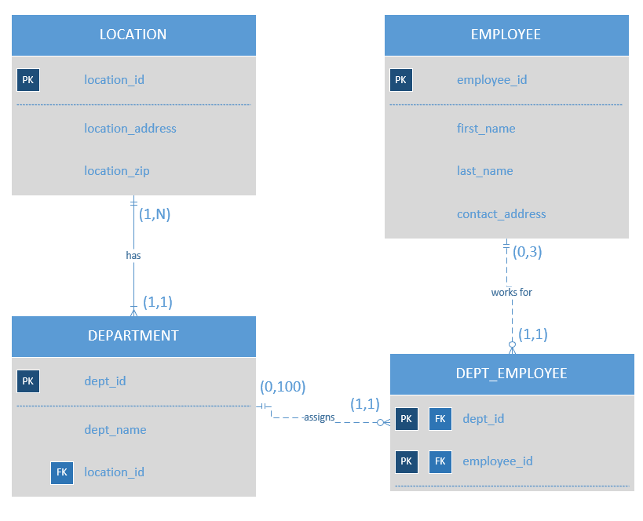

An employee can not be assigned to the same department for multiple times. Because, in the business rules it does not say that a department can consists of many projects. If a department can have many projects and an employee can work in several projects under the same department then we can say that an employee may be assigned to the same department for multiple times. As it is not stated so we cannot assign same employee in same department for multiple times.

**\*\* I did not explain the diagram in words as the question is asking only diagram. I only explain the last part of the question. Please let me know if I need to describe.**

**Practice Problem 02:**

**Solution:**

Rephrasing the business rules make it easy to implement the diagram.

Business Rules can be stated as follows:

* A patient can make many appointments with one or more doctors
* A doctor can accept appointments with many patients.
* An appointment yields one diagnosis
* An appointment may have one treatment.

Based on this business rules the following ER diagram can be followed. Notation is same as practice problem 01.

